ABORIGINAL STONE ARRANGEMENTS

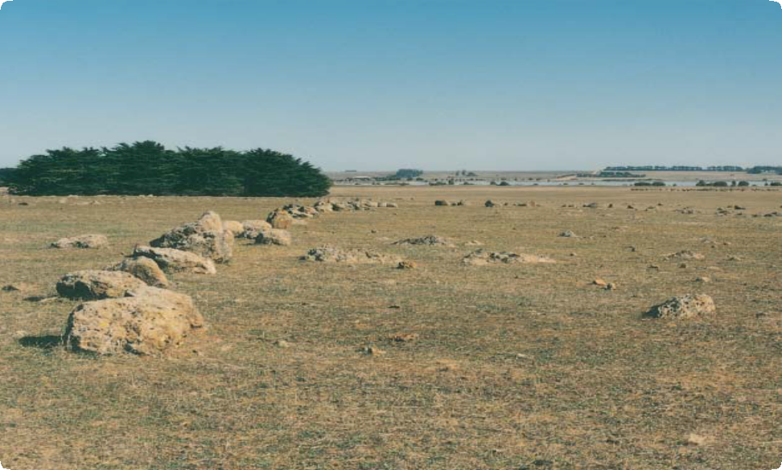

Lake bolac Stone Arrangement

# What are Aboriginal Stone Arrangements?

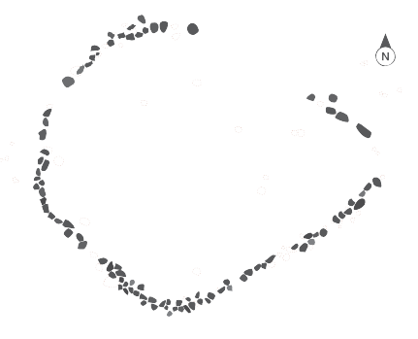

Place Identification

Mini Poster 10

**Characteristics**

* The stones and boulders are arranged in patterns or shapes such as large circles, animal shapes, boomerangs and mazes.
* Stone arrangements are usually large, measuring many metres across their width. They use stones in a range of sizes.
* The boulders have been moved to the site.
* Stone tools, animal bones, ochre, pipe clay and charcoal may be found in sediment from the arrangements.
* There may be information about the significance

of such places that has been passed down to contemporary tribes.

* Places may be difficult to identify without clearing vegetation.

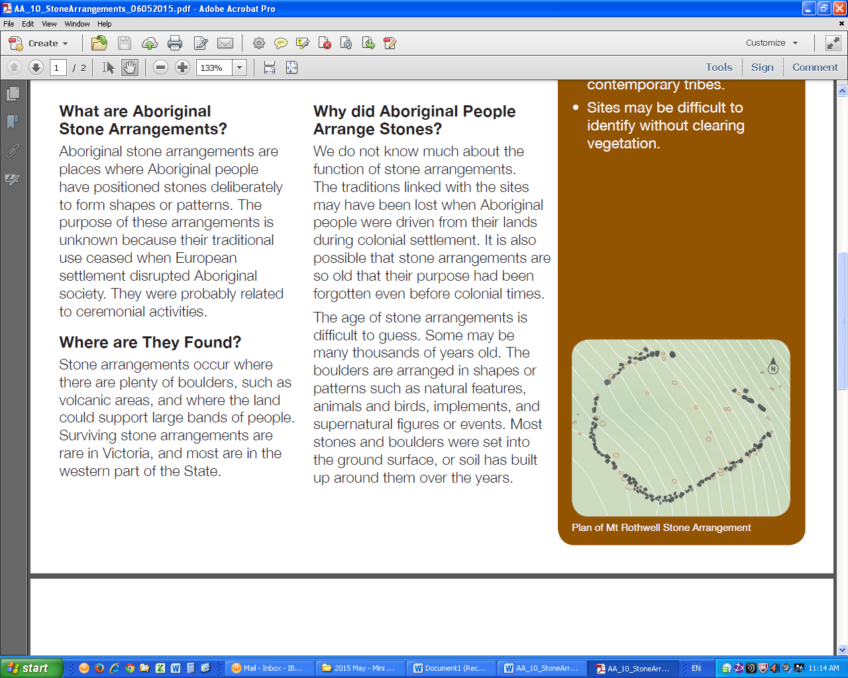

Plan of Mt Rothwell Stone Arrangement

Aboriginal stone arrangements are places where Aboriginal people have positioned stones deliberately to form shapes or patterns. The purpose of these arrangements is unknown because their traditional use ceased when European settlement disrupted Aboriginal society. They were probably related to ceremonial activities.

# Where are They Found?

Stone arrangements occur where there are plenty of boulders, such as volcanic areas, and where the land could support large bands of people. Surviving stone arrangements are rare in Victoria, and most are in the western part of the State.

# Why did Aboriginal People Arrange Stones?

We do not know much about the function of stone arrangements. The traditions linked with the places may have been lost when Aboriginal people were driven from their lands during colonial settlement. It is also

possible that stone arrangements are so old that their purpose had been forgotten even before colonial times.

The age of stone arrangements is difficult to guess. Some may be many thousands of years old. The boulders are arranged in shapes or patterns such as natural features, animals and birds, implements, and supernatural figures or events. Most stones and boulders were set into the ground surface, or soil has built up around them over the years.

If the boulders are moved or disturbed, a depression may be left in the ground.

Such places were probably used for ceremonies and rituals. These may have involved initiations and the passing on of secret lore about the spiritual life of Aboriginal people. Stone arrangements in other parts of Australia, including Tasmania, are known to have been ceremonial.

Large numbers of people could have gathered for ceremonies, but only when there was plenty of food. Daisy yams on the volcanic plains of western Victoria, or the eel runs in the rivers and wetlands of coastal Victoria, may have provided good

places for large seasonal gatherings.

# What about Other Stone Structures?

Both colonial settlers and Aboriginal people made stone structures. Settlers built hunting blinds, fish traps, houses, cairns and walls. Colonial structures were generally made from dressed stone and contain European artefacts Aboriginal people also made stone shelters, traps for fish and eels, and hunting blinds. All

these stone structures have obvious practical functions, unlike Aboriginal stone arrangements.

# Why are Aboriginal Stone Arrangements Important?

Aboriginal stone arrangements provide a rare glimpse into the fabric of past Aboriginal society. They

are an important link for Aboriginal people today with their culture and their past, particularly with the

spiritual and ceremonial aspects of Aboriginal societies.

# Are Aboriginal Stone Arrangements under Threat?

The stones are long lasting, but their arrangements can be damaged or destroyed. If stones are disturbed, the pattern and its significance may be lost.

Stone arrangements may be quite large and at least one example has been partly destroyed where it lay across the route of a roadway.

Ploughing, brush cutting, logging and large grazing animals can also cause disturbance.

Aboriginal Victoria records the location, dimensions and condition of Aboriginal stone arrangements.

The aim is to have a permanent written and photographic record of this important part of the heritage of all Australians. Management works around Aboriginal stone arrangements, such as stock, weed and erosion control, help preserve the sites for future generations.

# Are Aboriginal Stone Arrangements Protected?

All Aboriginal cultural places

in Victoria are protected by law. Aboriginal artefacts are also protected.

It is illegal to disturb or destroy an Aboriginal place. Artefacts should not be removed from site.

The arrangement places have a high spiritual value to Aboriginal people, so access to some places may require permission from the local Aboriginal community.

# What If You Find a Stone Arrangement?

Do not disturb the place or remove any material. Check whether the place has the typical characteristics of an Aboriginal stone arrangement. If it does, record its location and write a brief description of its condition. Note whether it is under threat of disturbance.

Please help to preserve Aboriginal cultural places by reporting their presence to Aboriginal Victoria.

Contact:

Heritage Services  
Aboriginal Victoria  
Department of Premier & Cabinet  
1 Treasury Place, Melbourne VIC, 3002

Telephone: 1800 762 003  
[Aboriginal.Heritage@dpc.vic.gov.au](mailto:Aboriginal.Heritage@dpc.vic.gov.au)

June 2008

Copyright State Government of Victoria 2008. Authorised by the Victoria Government, Melbourne

ISBN 978-1-921331-61-9

This publication may be of assistance to you but the State of Victoria and its employees do not guarantee that the publication is without flaw of any kind or is wholly appropriate for your particular purposes and therefore disclaims all liability for any error, loss or other consequence which may arise from you relying on any information in this publication.

<https://www.vic.gov.au/aboriginalvictoria/heritage.html>

cid:image001.png@01D4A28E.A22CFCA0