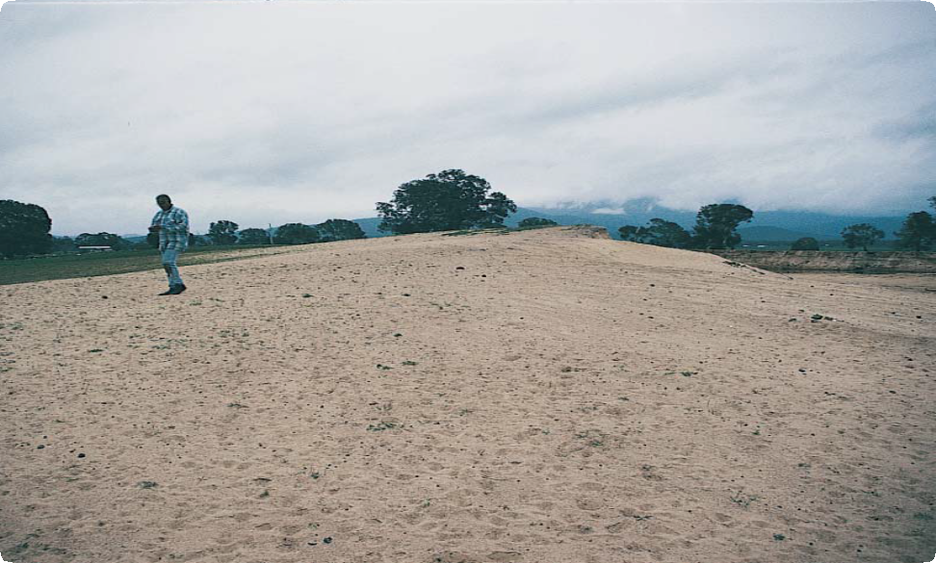

Place Identification

Mini Poster 5

**Characteristics**

* Aboriginal burials are normally found as concentrations of human bones or teeth, exposed by erosion or earth works.
* Remains may be scattered over a wide area, but

well-preserved remains occur as tight clusters about the size of a human body.

* Burials tend to be in soft soils and sand, although some burials also occur in rock shelters and caves.
* Recently exposed bones look ‘fresh’, and may be spotted or stained the colour of surrounding soil. Older remains may be covered by a smooth,

cement-like substance and be weathered grey or white in colour.

* Soil or sand around the bones may be stained with charcoal or ochre.
* Shell, animal bone and stone tools may sometimes be present.

ABORIGINAL BURIALS

Source-bordering dune. Aboriginal burials often occur in sand dunes near rivers and lakes

**What are Aboriginal Burials?** Aboriginal burials are normally found as clusters of human bones eroding

from the ground, or exposed during

ground disturbance.

Aboriginal customs for honouring and disposing of the dead varied greatly across Victoria, but burial was common. Aboriginal burial places normally contain the remains of one or two people, although cemeteries that contain the remains of hundreds of people buried over thousands of years have been found. Sometimes the dead person was buried with personal ornaments and artefacts.

Charcoal and ochre are also often found in burial places.

**Where are they Found?**Although Aboriginal burials are quite rare in Victoria, they have been found

in almost every kind of landscape,

from coastal dunes to mountain valleys. They tend to be near water courses or in dunes surrounding old lake beds. Many burials have been found on high points, such as dune ridges, within surrounding flat plains. They are often near or within Aboriginal occupation places such

as oven mounds, shell middens or artefact scatters.

# What to Do if You Find a Burial Place

Do not disturb the site or remove any material. You should immediately report any discovery of human remains to the police.

Also check whether the site has the characteristics of an Aboriginal burial. If it does, record its location and write a brief description of its condition. Note whether it is under threat of disturbance.

Please help to preserve Aboriginal cultural places by reporting their presence to Aboriginal Victoria.

Contact:

Heritage Services

Aboriginal Victoria

Department of Premier & Cabinet

1 Treasury Place, Melbourne VIC, 3002

Telephone: 1800 762 003

[Aboriginal.Heritage@dpc.vic.gov.au](mailto:Aboriginal.Heritage@dpc.vic.gov.au)

# How were Aboriginal Burial Places Produced?

Aboriginal people honoured and disposed of their dead in many different ways. The dead were usually buried in the ground, sometimes accompanied by possessions such as stone tools or personal ornaments. In some areas, special clothes were made for the deceased. Small fires were

often lit inside or near the grave, and sometimes ochre was sprinkled over the body. In some places, the grave was covered by a special structure such as a small hut or an earth mound, and its location was marked by other earthworks or by cutting bark from surrounding trees.

Other customs included placing the dead person on a wooden platform above the ground, sometimes in a tree, or wrapping the body in bark. After many months, the remains were collected for burial or deposited in a cave or rock crevice.

Aboriginal people were buried in the ground in a variety of positions.

Some were placed lying flat on their backs, legs fully extended or lying on their side in a crouched, or ‘foetal’ position. Others were buried in an upright sitting position.

The dead were buried either singly or in small numbers. The place of burial was either near the place where they happened to be camping at the time, or in cemeteries to which their relatives and descendants returned over hundreds, or even thousands, of years.

# Why are Aboriginal Burials Important?

Aboriginal burials have a particular significance for Aboriginal people today and provide important physical and spiritual connections with the land, culture and their past.

The places where the dead are laid to rest have always been important to humans. Burials provide an important link to the ancestral past, for they are physical evidence of

a set of spiritual beliefs that lasted many thousands of years. Burials also provide us with valuable information about past Aboriginal ways of life, including diet, health, population, economy and social structures. We can even trace changes in the ways Aboriginal people perceived and related to their environment by looking at the development of large-scale cemeteries.

**Threats to Aboriginal Burials** Although human bone can survive for a long time if buried, it deteriorates

rapidly once exposed. Many burials

are found on the edges of lakes and rivers, or in sand dunes that once lay near fresh water. Wind and water can readily expose and eventually destroy these places.

Because many burials are found

in loose soil or sand, they are often disturbed by burrowing animals such as rabbits.

Human activities such as sand mining, stock grazing, ripping rabbit warrens, ploughing and even trail bike riding can devastate burial sites.

Aboriginal Victoria records the location, dimensions, and context of Aboriginal burials so that we will have a permanent record of this important part of the heritage of all Australians. Management works, such as the eradication of rabbits, fencing and erosion control, are carried out so that Aboriginal burial locations can be preserved for future generations.

# Is it against the Law to Possess Aboriginal Skeletal Remains?

Yes. It is illegal to possess or display Aboriginal skeletal remains without a permit.

Anyone who has such remains is advised to contact Aboriginal Victoria, so that arrangements can be made for their appropriate treatment.

# Are Aboriginal Burials Protected?

All Aboriginal cultural places

in Victoria are protected by law. Aboriginal artefacts are also protected.

It is against the law to disturb or destroy an Aboriginal place. Artefacts should not be removed from site.

June 2008

Copyright State Government of Victoria 2008. Authorised by the Victoria Government, Melbourne

ISBN 978-1-921331-56-5

This publication may be of assistance to you but the State of Victoria and its employees do not guarantee that the publication is without flaw of any kind or is wholly appropriate for your particular purposes and therefore disclaims all liability for any error, loss or other consequence which may arise from you relying on any information in this publication.  
<https://www.vic.gov.au/aboriginalvictoria/heritage.html>   
cid:_2_09EEB8C809EEB474000FB0D8CA258371