# Aboriginal axe-grinding grooves

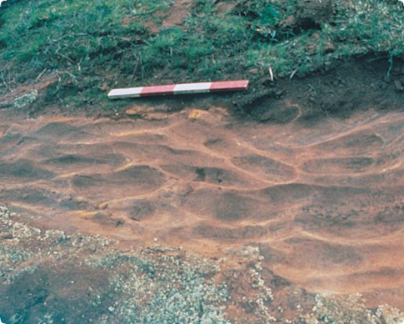

Typical axe-grinding grooves located on a low sandstone outcrop

**What are Aboriginal axe-grinding grooves?**

Axe-grinding grooves are oval-shaped indentations in sandstone outcrops. Aboriginal people made the grooves when they shaped and sharpened stone axes by grinding them against the sandstone.

Flat, low outcrops of fine-grained sandstone were used to give stone axe heads a sharp cutting edge.

Sometimes, Aboriginal people also carried small pieces of sandstone for sharpening axes, and these portable pieces were often gouged on more than one surface.

Other Aboriginal artefacts are sometimes found near axe-grinding grooves.

**Where are they found?**

Axe-grinding grooves are almost always found along the edges of rivers, creeks, lakes and swamps, or near dry or drained water bodies.

**How did Aboriginal people produce axe-grinding grooves?**

Aboriginal people used axe-grinding grooves to finish partly made axes (known as ‘axe blanks’) or sharpen axes that were worn or chipped.

Axe blanks are pieces of stone that Aboriginal people chipped into a basic axe shape at stone quarries and sharpened by rubbing the edges over sandstone. This rubbing action left grooves in the outcrop surface.

Aboriginal people often sprinkled water on the sandstone to make it more abrasive and to reduce dust. This is why the grooves are usually found on outcrops close to water.

**Why are axe-grinding grooves important?**

Places of Aboriginal axe-grinding grooves are rare. They provide valuable information about how stone tools were made. They increase our knowledge of past Aboriginal land use and ways of life.

Fact sheet number 12

Characteristics

* Shallow, oval-shaped grooves indent the surface of sandstone outcrops. The outcrops are usually low and rocky, and the sandstone has fine, uniform grains.
* The grooves are often in clusters of two to five. They range from 80 to nearly 500 millimetres in length. They can be up to over 200 millimetres wide and 100 millimetres deep.
* Places are generally found near water.

**Greenstone axes before and after grinding**

Axe-grinding grooves are an important link for Aboriginal people today with their culture and their past.

**Are axe-grinding grooves under threat?**

**Sandstone is a relatively soft stone that is gradually worn by weathering, erosion and trampling by animals such as cows and sheep. Human activities such as mining, road building, damming, clearing, ploughing and construction can also destroy these places.**

**First Peoples – State Relations records the location, dimensions and condition of Aboriginal grinding grooves. The aim is to have a permanent written and photographic record of this important part of the heritage of all Australians.**

**Management works around Aboriginal grinding grooves, such as stock and erosion control, help preserve the places for future generations.**

**Are Aboriginal axe-grinding grooves protected?**

**All Aboriginal cultural places in Victoria are protected by law. Aboriginal artefacts are also protected.**

**It is illegal to disturb or destroy an Aboriginal place. Artefacts should not be removed from site.**

**What should you do if you find axe-grinding grooves?**

**Do not damage or interfere with the sandstone outcrop or remove any material. Check whether the place has the typical characteristics of Aboriginal grinding grooves.**

**If it does, record its location and write a brief description of its condition. Note whether it is under threat of disturbance.**

**Please help to preserve Aboriginal cultural places by reporting their presence to First Peoples – State Relations.**

****Contact:** Heritage Services**

**First Peoples – State Relations**

**Department of Premier & Cabinet**

**1 Treasury Place, Melbourne VIC, 3002**

**Telephone: 1800 762 003**

[Aboriginal.Heritage@dpc.vic.gov.au](mailto:Aboriginal.Heritage@dpc.vic.gov.au)

We acknowledge the Traditional Owners of Country throughout Victoria and pay our respect to them, their culture, and their Elders past and present.

© State of Victoria (Department of Premier and Cabinet) September 2024

The State of Victoria does not guarantee that this publication is without flaw or is wholly appropriate for your purposes. We disclaim all liability for any error, loss or other consequence that may arise from your relying on any information in this publication.

To receive this document in an alternative format, phone **1800 762 003**, email **Aboriginalaffairs@dpc.vic.gov.au**, or contact National Relay Service on **1800 555 660** if required. HTML format is available at **firstpeoplesrelations.vic.gov.au**